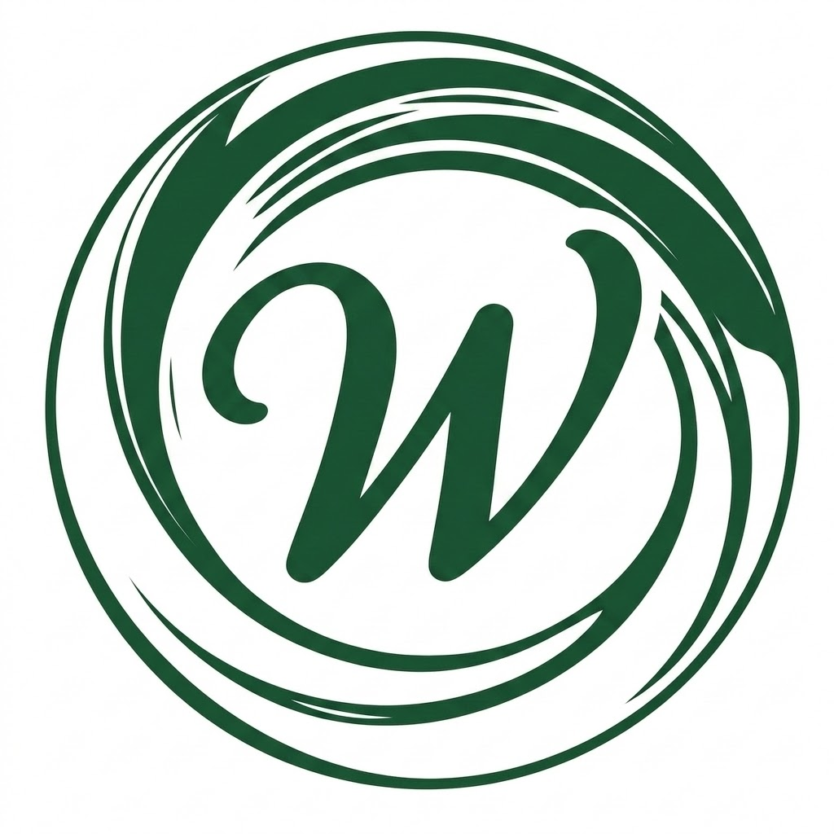
Prepared For
Kuriftu Resorts Team
Well Circle Progress Report
August 17 – September 27, 2026
Prepared By
Anteneh Yimmam
Product Manager, Well Circle Team
anteneh@wellcircle.et

TL;DR
Well Circle spent Aug 17 – Sep 27 building social and community presence, then, starting last week, began actively funneling that audience into the Telegram bot for the first time. The one standing product issue is the check-in habit loop: zero check-ins have been completed, and the event has not fired in production at all in over 90 days, despite strong nudge click-through and a growing backlog of at-risk streaks. (Booking confirmation is not yet a live pathway — no provider has bookings turned on yet, so 0% there simply reflects that no tester has had anything to confirm, not a defect.) On the community side, the team completed IDS integration readiness, held the in-person Aman/Sosina meeting, shipped a provider-domain migration, and kept a consistent wellness-event cadence — but the follow-up IDS Team meeting is still not scheduled, which is now the pacing item for the PMS integration path. Daily active testers grew from a peak of 3 to a peak of 6 (Sep 23), and that cohort showed the pilot's best retention yet (66.7% Day-1). Last week the team shipped a UI redesign and began actively funneling social and event audiences into the Telegram bot for the first time — the prior five weeks were spent building social and community presence rather than driving bot traffic. Afroheat Fitness was also contacted as a potential new partner (pending). Social performance is a split picture: LinkedIn posting cadence collapsed (1 tracked post vs. 7 last period) and organic impressions fell to 453, while Instagram grew to 5,503 views / 317 interactions (up from 3,217 / 103) and TikTok posted the strongest growth of any channel — 6.5K views (+166%) and 38 followers, up from a near-zero base.
Metric | Result | Status
Daily active testers (peak) | 6 users (Sep 23), up from 3 | 🟡 Growing, still small
Check-in completion rate | 0% — broken since Aug 2 | 🔴 Critical, unresolved
Streak-at-risk backlog | 202 events, 8× spike since Sep 8 | 🟡 Growing engagement, blocked
Circles created | 0 in 30/90 days | 🔴 Dead
IDS Team meeting | Not yet scheduled | 🔴 Blocking PMS path
Bot-funnel push & UI redesign | Started last week (Sep 21–27) | 🟡 Just launched
Afroheat Fitness partnership | Contacted, pending | 🟡 In progress
LinkedIn organic impressions | 453 (30 days) — posting cadence collapsed | 🔴 Declining
Instagram views | 5,503 (30 days), up from 3,217 | 🟢 Growing
TikTok views | 6.5K (28 days), +166% vs. prior period | 🟢 Growing fast

Executive Summary
This report covers Well Circle's operational status, community growth, and product performance for the Kuriftu Resorts wellness pilot, spanning August 17 – September 27, 2026. Well Circle remains in the pre-launch integration phase: IDS integration engineering work is complete, but the follow-up IDS Team meeting to finalize scheduling and the provider pricing list has not yet been set, and the partnership agreement signing is still pending.
Product analytics for the trailing 30 days (Aug 28 – Sep 27, sourced from PostHog) confirm the hard blocker flagged last period has not moved: check-in completion is still at 0%, and the check-in event itself has not fired in production since August 2 — meaning every downstream reward event (streak milestones, personal bests, comeback bonuses) remains structurally unreachable. Booking confirmation also sits at 0% in the funnel, but this reflects the pilot's current stage rather than a defect: no provider has live bookings turned on yet, so there is nothing for a tester to confirm. The one genuinely positive signal on the check-in side is that the accumulation of at-risk streaks (202 events, an 8× volume increase since Sep 8) shows real user engagement building up behind a broken pipe — fixing check-in would immediately test a real, motivated cohort.
Community-side, the team shifted further toward embedding in existing wellness events (Greatrun, Birtusew) rather than running standalone ones, kept a consistent weekly events cadence, and closed the loop on post-event circle creation — though circle joins remain entirely invite-link-driven (0 organic joins through onboarding) and no new circles have been created in 90 days. The first five weeks of this period (Aug 17 – Sep 20) were focused on building social and community presence; last week the team shipped a UI redesign and began actively funneling social and event audiences into the Telegram bot for the first time, and reached out to Afroheat Fitness as a potential new partner (pending). Social performance diverged by channel: LinkedIn organic reach continued the decline flagged last report, compounded by posting cadence dropping to roughly one tracked post versus seven previously, while Instagram grew on both views and interactions and TikTok posted the strongest channel growth of the period (6.5K views, +166%).

1. Recent Accomplishments (Aug 17 – Sep 27)

Key Meetings & Stakeholder Alignment
- Aug 23 (Team Sync): Reviewed social account consolidation, in-person event onboarding results, and confirmed IDS integration readiness on the engineering side.
- Aug 30 (Team Sync / In-person): Met with Aman and Sosina in person to finalize IDS scheduling and the provider pricing list; Aman linked the team with the main IDS team. Chatbot event-support (RAG) work and webapp access handoff to marketing were scoped.
- Sep 5–13: Implementation plan finalized for the about-page and RAG/security changes proposed by the team (~50% shipped); IDS team contacted directly to set up a follow-up meeting.
- Sep 20: Website design and font corrections shipped; this week's events wired into the bot with a dropdown for details.
- Also shipped in this window: provider-domain migration (removing the Telegram-only provider option in favor of provider.wellcircle.et), events-page improvements on both the bot and webapp, and the start of event-aware RAG support in the chatbot.
- Open item: The IDS Team follow-up meeting has not yet been scheduled — this is now the critical path item for the PMS integration timeline.

Aug 17 – Sep 20 (5 Weeks): Social & Community Presence
The first five weeks of this period were spent building social and community presence rather than driving traffic into the product — laying the groundwork the last week's bot-funnel push now builds on.
- QR code partner stand (wellcircle.et/visit?src=boston-day-spa) remains live and continues generating tracked referral visits — confirmed as a real, trackable acquisition channel worth building a dedicated cohort around.
- Continued embedding in existing wellness communities rather than running standalone Well Circle events: joined Greatrun, Birtusew, and the 19K event.
- “Create circle after event” workflow (story upload + circle banner) shipped, closing the loop between in-person events and in-app community formation.
- Hanna onboarded into a brand role and completed probation review, with access to email and socials; real brand assets (logo, past-event photos, color theme) delivered for the explainer video.
- Kept a consistent weekly presence across LinkedIn, Instagram, and TikTok with wellness-events roundup content — the cadence that is now paying off most visibly on Instagram and TikTok (see Section 6).
- New Year wellness-event outreach to partner communities (African Village, Birtusew, Satenaw) kicked off — status: pending as of Sep 20.
- Explainer video: script, footage generation, and asset gathering are underway; pinning the finished video across channels is still pending.

Sep 21 – Sep 27 (Last Week): Funneling Users Into the Bot
- UI redesign shipped across the bot/webapp experience — the first concrete step toward converting social and event audiences into product users.
- Started actively funneling users into the Telegram bot for the first time this pilot — directing social and in-person event audiences toward @wellcirclebot rather than just building awareness.
- Contacted Afroheat Fitness as a potential new wellness partner — status: pending.
- GitHub Education deployment option configured for the bot.

2. High-Level Well Circle Progress Timeline & Governance
Phase | Window | Status | Key Deliverables
Phase 1: Stabilization | Aug 03 – Aug 09 | Completed | Kuriftu onboarded as primary provider, QR codes generated, staff booking export live.
Phase 2: Pre-Launch Integration & Agreement | TBD | In Progress | IDS integration readiness complete; IDS Team follow-up meeting not yet scheduled; partnership agreement signing and provider readiness ongoing. Onboarding of 4 external wellness providers and community group integration continues.
Phase 3: Review Window | TBD | Upcoming | Joint feasibility review against agreed PostHog analytics.
Go/No-Go Decision | TBD | Scheduled | Final executive evaluation for long-term expansion.

3. PMS Integration Progress (FortuneNext 7.0 by IDS Next)
Engineering-side readiness work is complete, but scheduling the follow-up IDS Team meeting — needed to finalize integration timing and the provider pricing list — remains an open item with no date set. PMS integration stays in-scope to automate the booking flow from Well Circle's Google Sheets export directly into Kuriftu's front-office system.
- Current System: FortuneNext 7.0 PMS (2 integrated modules).
- Primary Integration Path (Option A): Connecting Well Circle's API to Kuriftu's active “Revenue & Distribution Connect” channel manager.
- Fallback Integration Path (Option B): Automated CSV/XML scheduled file drop directly into FortuneNext Front Office, eliminating manual staff entry.
- Post-Launch Strategy (Option C): Formal IDS Next Partner Marketplace integration for long-term real-time synchronization.

4. Well Circle Performance Report (30-day PostHog window, Aug 28 – Sep 27, 2026)
This section reflects the PostHog pilot-effectiveness and identity/habit-loop dashboards for the trailing 30 days. Most of that window (Aug 28 – Sep 20) predates the active bot-funnel push, so the low volumes through most of it reflect the social-presence-building phase rather than the funnel underperforming; the meaningful read starts with last week (Sep 21–27), when the team began directing users into the bot for the first time — and it's no coincidence that the DAU peak and best retention cohort both land in that exact window. The check-in habit loop is the one issue that predates and is independent of the funnel push: it has not fired in production at all in 90+ days.

New-Customer Funnel
Step | Users | Conversion (overall) | Drop-off
app_open | 15 | 100% | –
explore_view | 12 | 80% | 20%
booking_start | 6 | 40% | 60%
booking_confirmed | 0 | 0% | 100%
The first two steps convert well — 80% of testers who open the app explore content, and 40% of explorers go on to start a booking, which is a healthy intent signal this early. Booking confirmation sits at 0%, but no provider has live bookings turned on yet, so there is nothing for a tester to confirm at that step — this is expected for the pilot's current stage, not a product defect. It's a step worth re-measuring once a provider goes live with real bookings.

Daily Active Testers & Retention
- Peak DAU grew from 3 (late August) to 6 on Sep 23, with the strongest window being Sep 22–24 — this lines up directly with the team starting to actively funnel users into the bot that same week.
- The Sep 23 cohort (the peak-DAU group) shows the pilot's best retention yet: 66.7% Day-1 and 16.7% Day 2–3 — a genuinely promising early signal.
- Outside that cohort, most groups drop to 0% retention from Day 1 onward; no cohort has sustained retention beyond a few days, and the Aug 28 cohort's one persistent power user remains an outlier rather than a pattern.

Check-in Habit Loop
Step | Users | Conversion | Drop-off
checkin_prompt_view | 5 | 100% | –
checkin_prompt_click | 4 | 80% | 20%
checkin | 0 | 0% | 100%
The streak nudge itself works well — 80% click-through means the prompt copy and placement are effective. But the check-in event has not fired in production since August 2, before this pilot's tracked window even began, confirming this is a standing bug rather than a recent regression. Because checkin never fires, streak_milestone, streak_personal_best, and comeback_bonus have zero events across their full 90-day history — the entire reward flywheel is stalled behind this one fix.
Positive signal buried underneath: streak_risk_view volume is accelerating sharply — from ~11 events in the Aug 28–Sep 7 window to ~94 in Sep 8–18 and ~90 sustained through Sep 26 (an 8× increase). This means a real, growing backlog of users have built multi-day streaks the system is trying to protect. Once check-in is fixed, this cohort is an immediate, motivated test of whether the milestone/comeback rewards actually drive re-engagement.

Circles: Create / Join / Invite
- 30-day totals: 0 circles created, 12 joined, 1 invite shared. Zero circles have been created in 90 days — circle creation is functionally dead.
- Every join is invite-link driven: a Sep 2 burst of 7 joins tracks to a single link shared outside the app (likely a Telegram group), not to in-app discovery.
- 0 of 5 onboarding completions led to a circle join — the onboarding → circle prompt is not converting, even though circles are the strongest organic social signal the pilot has.

Rewards & Share Cards
- Rewards redemption starts: 2 events total in 30 days (Sep 5 and Sep 13) — effectively zero, and structurally gated behind booking confirmation, which isn't live with any provider yet.
- Share card data quality issue: 48 downloads were logged against only 11 shows in the same 30-day window — mathematically impossible in a normal flow, and the clearest sign the share_card_shown event is not firing consistently. This should be fixed before drawing any conclusions about share-card performance.

Services Explored by Category
Category | Events (30d) | Share of categorized
Gym | 28 | 42%
Yoga | 19 | 29%
Nutrition | 10 | 15%
Spa | 6 | 9%
Therapy | 2 | 3%
Other | 1 | 2%
Gym and yoga together account for 71% of categorized interest and remain the pilot's showcase categories. 185 of 251 total explore_view events (74%) still fire without a category tag — the same tagging gap flagged last report has not been closed and continues to limit how much of this data can be trusted.

5. Priority Action Items
Priority | Action | Rationale
🔴 P0 | Fix the checkin event | Has not fired since Aug 2. Every downstream reward, retention, and habit-loop metric is blocked by this one bug — and a growing, engaged streak-at-risk cohort (202 events) is waiting on it.
🔴 P0 | Schedule the IDS Team follow-up meeting | Not yet scheduled. This is now the pacing item for the entire PMS integration path and the provider pricing list.
🟡 P1 | Fix share_card_shown event firing | Downloads (48) exceed shows (11) in the same window — the shown event is being dropped, making share-card analytics unreliable.
🟡 P1 | Add a circle_joined prompt to onboarding | 0 of 5 onboarding completions led to a circle join, yet circles are the strongest organic social signal in the data.
🟡 P1 | Restore LinkedIn posting cadence | Roughly one tracked post this period vs. seven the period before, tracking with a continued organic reach decline.
🟡 P1 | Track results of the new bot-funnel push | Funneling users into the bot only started last week (Sep 21–27) — instrument this now so next report can measure conversion from social/event traffic into the bot.
🟡 P2 | Tag explore_view with category consistently | 74% of explore events remain untagged, limiting confidence in the category-interest data.
ℹ️ P3 | Grow the tester cohort | 6 peak DAU is still too small for confident conclusions; aim for 20–30 active testers for reliable funnel data.

6. Social Media Performance
Note: this section covers LinkedIn, Instagram, and TikTok for the period.

LinkedIn
Organic LinkedIn reach continued to soften this period: 453 organic impressions, 47 clicks, and 10 reactions over the trailing 30 days (Aug 27 – Sep 25), against 548 impressions and 22 clicks reported for Aug 17–29 last period, and 1,569 impressions / 371 clicks two periods ago. The steeper story is cadence: the export shows only one fully tracked organic post this period (Sep 1: 51 impressions, 2 clicks, 3 likes), compared with seven posts across the prior two-week period. The recommendation from last report — reintroduce narrative/brand-story posts alongside the events cadence — does not appear to have been acted on yet.
Metric (30 days, Aug 27–Sep 25) | This Period | Prior Period
Impressions (organic) | 453 | 548 (Aug 17–29)
Clicks (organic) | 47 | 22 (Aug 17–29)
Reactions (organic) | 10 | 46 (Aug 17–29)
Avg. daily engagement rate (organic) | ~10.3% | ~12.4% (Aug 17–29)
Tracked organic posts | 1 | 7 (Aug 17–29)
Days with zero recorded organic impressions rose to 4 out of 30 in this window, versus scattered zero-days previously — consistent with a near-empty LinkedIn posting calendar for most of September. Recommendation carried forward: resume at least weekly LinkedIn posting, mixing event-roundup content with narrative/brand posts, which drove disproportionately higher engagement in earlier periods.

Instagram
Instagram is the one channel that kept a real posting rhythm through this period, and it shows: 5,503 total views and 317 interactions over the trailing 30 days (Aug 28 – Sep 27), up from 3,217 views and 103 interactions in the prior 14-day window. Non-followers still make up the majority of viewers (63.3%, essentially flat versus 64% last period) — content continues reaching well beyond the existing audience. The top-content list includes wellness-event roundup graphics dated into September (Sep 2 and Sep 13–14 listings), confirming the events-post cadence held here even as it collapsed on LinkedIn.
Metric (30 days, Aug 28–Sep 27) | This Period | Prior Period
Views (all content) | 5,503 | 3,217 (Aug 17–31, 14d)
Viewers | 1,926 | 1,311
Interactions | 317 | 103
Profile visits | 150 | 67
Bio link taps | 4 | 2
Non-follower share | 63.3% | 64%

Views & interactions by content type
Content Type | Views | Interactions
Posts | 2.6K | 89
Reels | 2.5K | 197
Stories | 451 | 31
Live videos | 0 | 0
Reels have flipped the interaction pattern from last report: they now drive the most interactions by a wide margin (197, more than double Posts' 89) despite similar view counts — previously Posts and Reels were roughly tied on interactions (44 vs. 42). Top individual content by views: two street/run reels (1.3K and 1.1K) and two wellness-events roundup graphics (910 and 242). Bio link conversion is still low — only 4 taps from 150 profile visits (2.7%) — the same “book now” CTA gap flagged last report remains unaddressed.

TikTok
TikTok delivered the strongest growth of any channel this period: 6.5K post views over the trailing 28 days (Aug 29 – Sep 25), up +166% from 2.6K the period before, alongside sharp gains in every engagement metric. Net new followers hit 28 this period (+250%), pushing the account's all-time total to 38 — meaning most of the account's followers to date joined in just the last 28 days.
Metric (28 days, Aug 29–Sep 25) | This Period | Prior Period (28d)
Post views | 6.5K | 2.6K
Profile views | 90 | 23
Likes | 180 | 49
Comments | 5 | 0
Shares | 98 | 6
Total viewers | 4.5K | —
Net new followers | 28 (+250%) | —
Traffic remains almost entirely algorithm-driven — 88.1% from the For You feed, 7.2% personal profile, 4.2% search — consistent with the prior period's pattern, though the top search queries this period are far more scattered (five different queries tied at 0.4% each, spanning general Addis Ababa/fitness terms) versus last period's clear concentration around “vahe zumba addis ababa” (14.8%) and the brand name itself. This suggests broader, more organic discovery, though at these low percentages it's directional rather than conclusive.
Top content by views: the two Bertusew/Satenaw running-club reels (1,100 and 924 views, 900 and 884 new viewers respectively) continue to lead, with wellness-events roundup graphics following behind (456 and 429 views). Viewer base skews female (60% vs. 40% male), and the audience is most active late Saturday night (12–1am) — worth timing posts around. No revenue signal yet (est. rewards $0.00), which is expected at this scale.

7. Immediate Action Items & Executive Support Required
- Well Circle Team: Escalate the 0% check-in completion bug as the top engineering priority — it has not fired in production in 90+ days and blocks the entire reward flywheel.
- Aman (IT): Confirm a date for the IDS Team follow-up meeting with Anteneh and Sosina — this is now the blocking item on the PMS integration timeline.
- Sosina (Marketing): Provide the finalized wellness-service and pricing list to unblock point-value calibration.
- Mahlet & Sosina: Review the suggested post about Well Circle's story at Kuriftu African Village before it goes out.
- Kuriftu Team: Introduce Well Circle to Hamrawit (Afro Heat), Kidist (Yene Health), and Dehorah (Wevasphere) to help move those partner conversations forward.
- Mahlet (Executive Leadership): Confirm placement locations for additional physical QR code materials at the resort, building on the Boston Day Spa stand's continued traction.
- Well Circle Team: Add a Day-0 → Day-1 re-engagement trigger (push or Telegram message) to build on the momentum from last week's bot-funnel push.

Appendix: Reference Documents
- Wellcircle Progress Report [Aug 17–31]
- Marketing Team Notes
- IDS_Integration_Meeting_Notes
- Well Circle & Kuriftu Pilot Partnership Agreement
- Meeting with Sosina (Aug 30)
Product Analytics: PostHog AI pilot-effectiveness report and identity/habit-loop dashboard, Aug 28 – Sep 27, 2026.

